**Executing a Script**

Task :

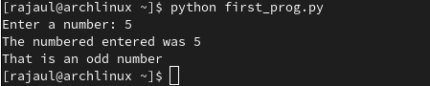

Task:

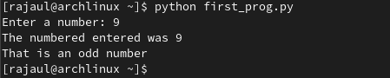

Task:

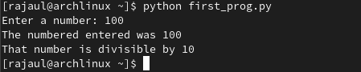

**Command Line Arguments**

Task:

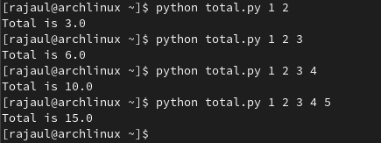

Task:

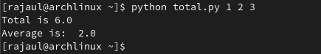

Task:

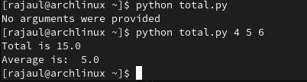

**Writing Modules**

Task:



Task:

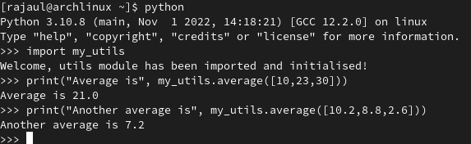

**Methods of Importing**

Task:

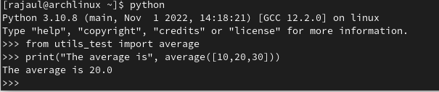

**Listing Symbol Table Names**

Task:

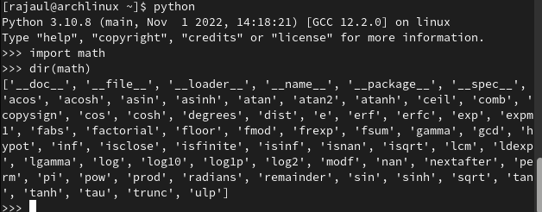

Task:

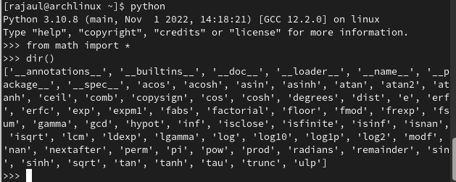

**The Module Search Path**

Task:

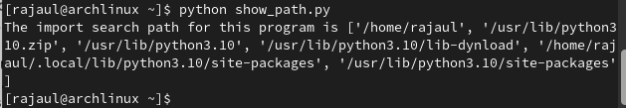

**Writing a ‘Script’ and ‘Module’**

Task:

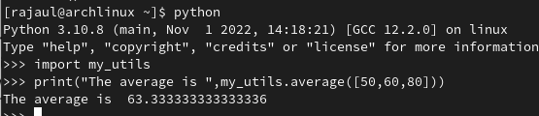

**Key Terminology**

**● IDE:** An integrated development environment (IDE) is a [software application](https://en.wikipedia.org/wiki/Application_software) that provides comprehensive facilities to [computer programmers](https://en.wikipedia.org/wiki/Computer_programmer) for [software development](https://en.wikipedia.org/wiki/Software_development).

**● Module:** A module is a section of code that is added in as a whole or is designed for easy reusability.

**● Command Line Arguments:** Command-line arguments are simple parameters that are given on the system's command line, and the values of these arguments are passed on to your program during program execution.

**● Symbol-table:** Symbol Table is an important data structure created and maintained by the compiler in order to keep track of semantics of variables.

**● Search path:** The search path, or path is a subset of all the folders in the file system that MATLAB uses to locate files efficiently.